Resources and advice for supporting children, families and staff about coronavirus

Information on potential risk factors for experiencing particularly heightened levels of anxiety

This specific pandemic is very new, meaning that we are still learning about psychological responses to coronavirus and the measures being put in place to manage risk levels associated with coronavirus. However, psychological theory might suggest that the following groups of individuals might be at greater risk of experiencing high levels of anxiety as a result of the threat of coronavirus:

- Individuals who experience high levels of anxiety more generally, or who experience health-related anxiety
- Individuals who have experienced the death of a key attachment figure (e.g. a parent, carer, or other close relative), particularly if the figure died of a similar condition
- Individuals with close family members who are at high risk (either through age or a pre-existing condition), or who are at high risk themselves
- Individuals who ‘over-expose’ themselves to concerning and potentially inaccurate information about coronavirus.

Behaviours associated with high levels of anxiety or perceived threat might include:

- Carrying out extensive research into coronavirus (to the extent that this interferes with other daily activities)
- Compulsive handwashing
- Being unable to sleep
- A reluctance to attend nursery/school/college – reduced attendance
- New heightened anxiety on separating from the primary caregiver.

Resources that might be helpful for children and their families understanding coronavirus

Resources to use with children:
- A story written for young children to help explain the upcoming over-70s isolation – Cosy Time (see attached)
- ELSA story https://www.elsa-support.co.uk/coronavirus-story-for-children/
- A comic exploring coronavirus to help young people understand https://www.npr.org/sections/goatsandsoda/2020/02/28/809580453/just-for-kids-a-comic-exploring-the-new-coronavirus?t=1584464333506
- A booklet for young children about Coronavirus https://www.mindheart.co/descargables

Videos:
- A Newsround clip
- Video, useful for Y3 – Y7 https://www.brainpop.com/health/diseasesinjuriesandconditions/coronavirus/
- Information video on Coronavirus for older children/adults, by WHO:
https://www.youtube.com/watch?v=mOV1aBVYKGA&feature=youtu.be

Social stories:
- Online social story https://carolgraysocialstories.com/wp-content/uploads/2020/03/Pandemics-and-the-Coronavirus.pdf?fbclid=IwAR23zxNlbEumpw4oKlM7Xy3VlKnA25b8Gi53N6YiFIeKB9Vx0LQypSPYzzg

Talking to children:

- MIND publication: https://www.mind.org.hk/wp-content/uploads/2020/02/ResponseCoronavirusENG6.2.2020-.pdf
- Some useful information about what to say to children re Covid-19 from Norway, can be adapted
https://krisepsykologi.no/what-can-we-say-to-children-about-coronavirus/
- The Unicef website, in particular the section on how to talk to your child
- The YoungScot website
- The British Psychological Society website https://www.bps.org.uk/news-and-policy/talking-children-about-coronavirus
- https://www.mencap.org.uk/advice-and-support/health/coronavirus
- Attached document ‘Talking to children and young people about coronavirus’ includes a model that may provide a useful framework for talking to children about coronavirus.

Resources and tips for staff, children and family members who are hoping to reduce their levels of anxiety

- Try reducing your exposure to media coverage of coronavirus, particularly if the information is likely to be misleading, inaccurate or sensationalising. Try restricting yourself to particular sources of key information (e.g. UK Government Response and NHS advice)
- Be mindful of what children might be overhearing on the news or from adults and other children, and let children know that they can talk to you about anything they might be worried about
- Try the BBC’s ‘Seven Techniques for Helping Kids Keep Calm’
- Mind guidance Managing our Mental Health and Staying Well during Virus outbreak
https://www.mind.org.hk/wp-content/uploads/2020/02/ResponseCoronavirusENG6.2.2020-.pdf
- Blog post from Educational Psychology insight around self-care
https://www.epinsight.com/post/managing-stress-self-care-during-the-coronavirus-crisis
- https://www.specialneedsjungle.com/calming-coronavirus-anxiety-children-everyone-else/
- https://www.tyla.com/life/life-coronavirus-tips-keep-kids-calm-covid-19-children-explain-20200317
- Young minds offer helpful information to parents about talking to children and young people about coronavirus:
https://youngminds.org.uk/blog/talking-to-your-child-about-coronavirus/
- Young minds have a useful blog for young people to access themselves:
https://youngminds.org.uk/blog/what-to-do-if-you-re-anxious-about-coronavirus/

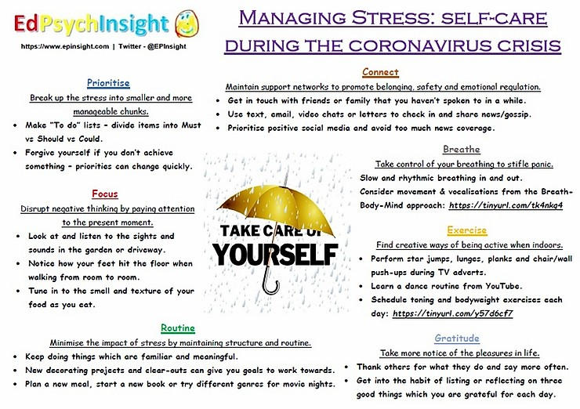

Advice for parents
Helping children manage in unsettling times

The coronavirus outbreak has led to a high degree of worry, uncertainty and concern. The issue has been very present in the news, and all adults and children will have some degree of awareness of events so far, and may have had their lives disrupted.
During these times both children and adults can potentially feel anxious and unsure about their safety. Alongside school, parents can help provide opportunities where feelings can be discussed within a safe context, as well as maintaining a sense of normality, routine and calm. Supporting children will enable them to process and manage their feelings and build resilience.

The following suggestions may be helpful:
- Reassure children that they are safe: Children will need to be reassured regularly they are safe, and that adults will faithfully try to keep them safe.

- Let children know that it is alright to be upset: Tell children all feelings are ok, but it is important to still behave in a polite and respectful way to others.

- Maintain a normal routine: Set up a work/leisure/exercise routine for students at home. Make extra time to listen to what your children need to tell you.

- Place an emphasis on resilience and strengths: Focus on the child’s skills, in terms of their daily life. Help them see they have many strengths to help them cope if feeling anxious or upset.

- Look for opportunities to help others: Acts of benevolence, charity and humanity help to restore positivity about the world.

- Provide opportunities for children to be honest about their feelings: Sharing worries or feelings of upset with other family members reduces a sense of vulnerability and isolation, raises optimism and self-esteem. Checking in with your children to see if they have any worries can help them start these conversations.

- Provide opportunities for physical exercise: Exercise is valuable in developing natural chemicals in the brain to help us cope with feelings such as shock and worry.

- Communicate any concerns with school: If you have any worries or concerns about your child’s emotional behaviour please do let the school know.

- Look after yourself: A time of stress can mean less energy and more potential for illness for you, as well as others. So please take care of yourself.

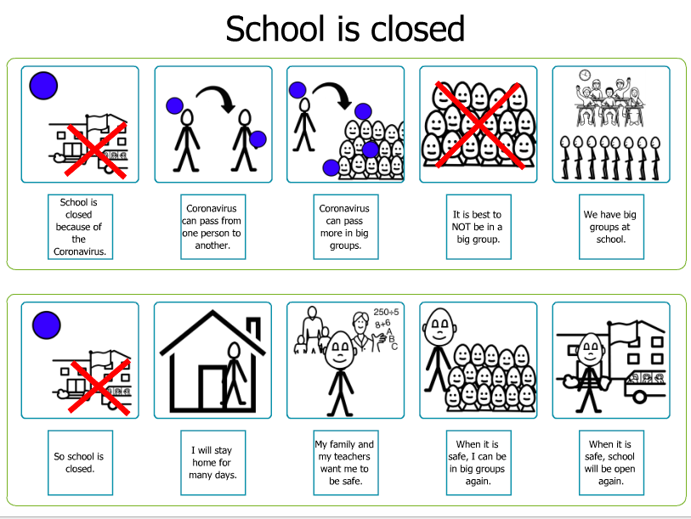

Social story from @ZonesofReg – in case of closure
NB this social story implies that adults can keep children safe, however, caution needs to be exerted when using the social story as this is not necessarily the case in current climate

